**Final District Analysis**

It was noticed that the math and reading scores for the 9th grade class at Thomas High School were incorrect, so their scores were removed from the analysis without removing the students themselves.

1. **How is the district summary affected?**

The removal of Thomas High School 9th graders had a minimal effect on the district summary – the Average Math and Reading scores stayed the same, while the % Passing Math, Reading, and Overall all lowered by about 1%.

Before Thomas High School was removed:

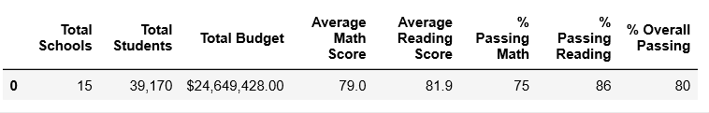

After Thomas High School was removed:

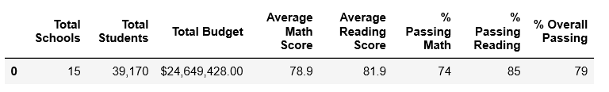

1. **How is the school summary affected?**

The school summary was only affected for Thomas High School, where the % Passing Math decreased from 93.3% to 66.9%, Reading decreased from 97.3% to 69.7%, and Overall Passing decreased from 95.3% to 68.3%. The Math and Reading Averages roughly stayed the same, with only changing by -0.05% and +0.05%, respectively.

School summary before:

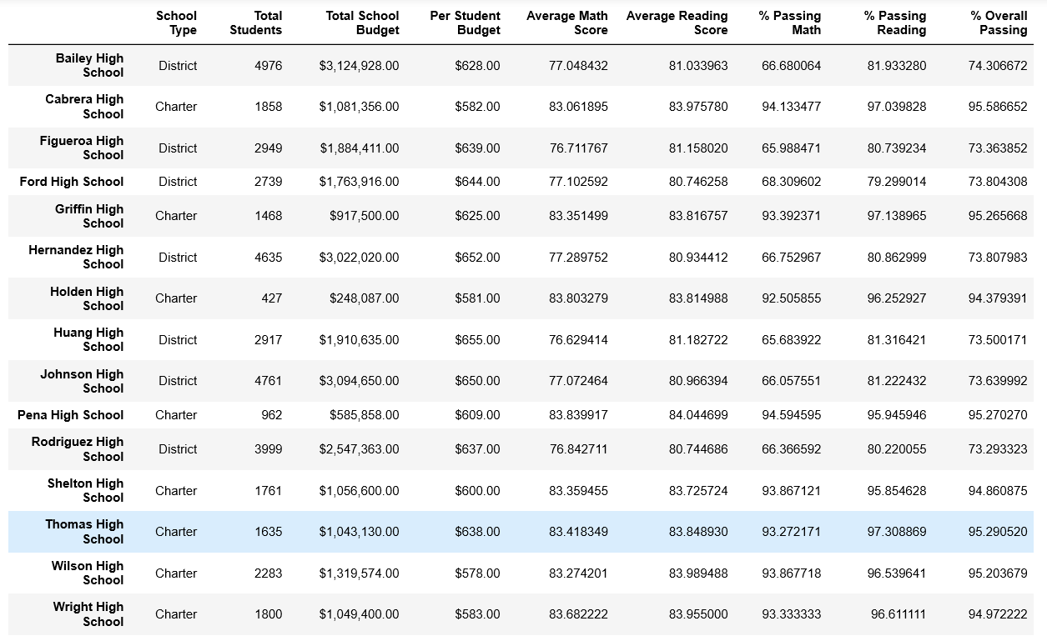

School summary after:

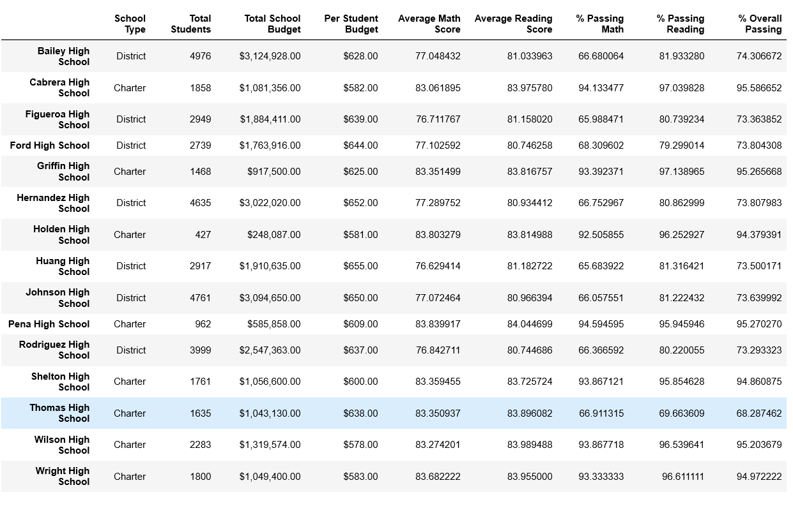

1. **How does removing the ninth graders’ math and reading scores affect Thomas High School’s performance, relative to the other schools?**

The removal of Thomas High School 9th graders had a great impact on the overall placement of the school in comparison to others. Before the class scores were removed, Thomas High School ranked second place in the top five based on the % Overall Passing, with a 95.3%. However, once the class scores were replaced with NaN, it moved to the lowest ranking with a % Overall Passing of 68.3%. This can be seen in the table ‘Bottom scores after’.

Top schools before:

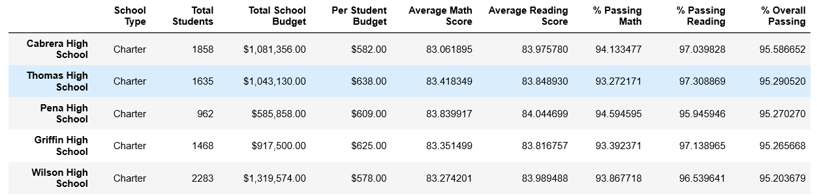

Top schools after: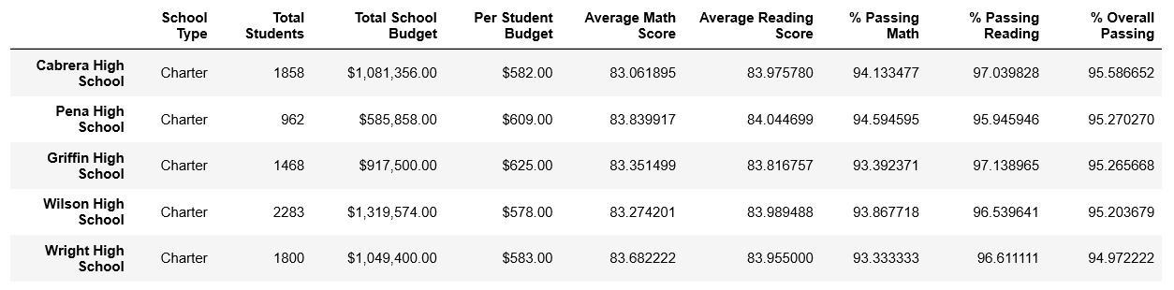

Bottom schools before:

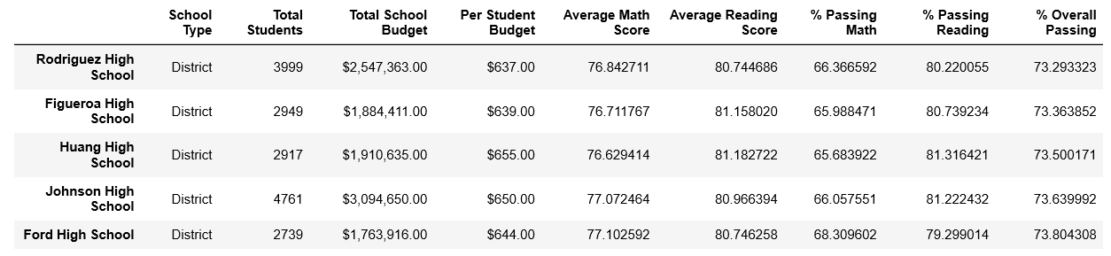

Bottom schools after: 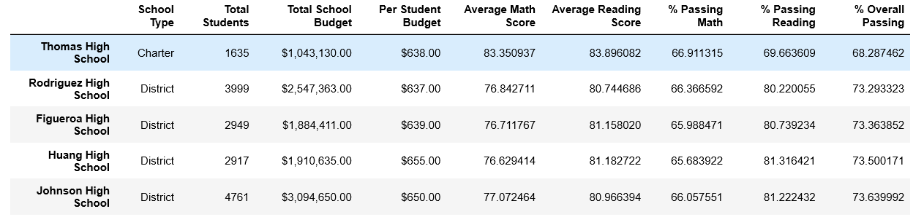

1. **How does removing the ninth grade scores affect the following:**

**Math and Reading Scores by Grade:**

Removing the scores from the 9th grade class at Thomas High School made no impact on any other school, or even to the other grade classes at Thomas High School. The only thing affected were the math and reading scores being replaced with “nan” values for the 9th grade class at Thomas High School.

Math scores before: Math scores after: 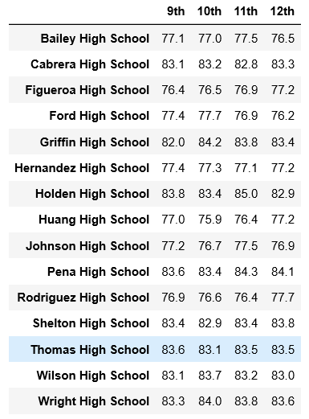 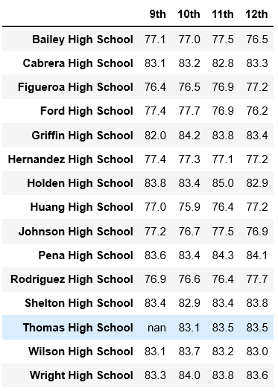

Reading scores before: Reading scores after:

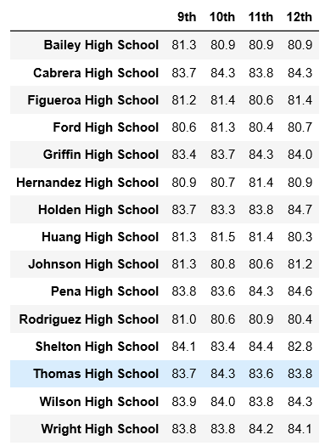 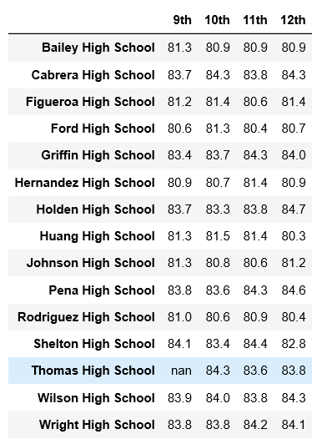

**Scores by School Spending:**

Thomas High School was in the $630-$644 spending per student bin and when their scores lowered for % Passing Math, Reading, and Overall Passing, it dropped the bins overall percentage by 6-7%. The Average Math and Reading scores were not affected.

Scores by spending before:

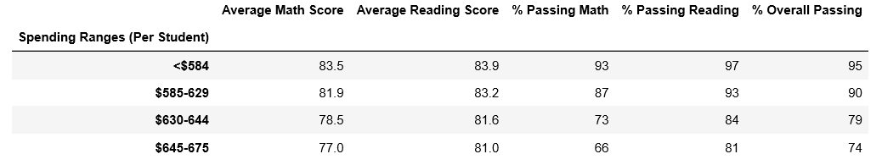

Scores by spending after:

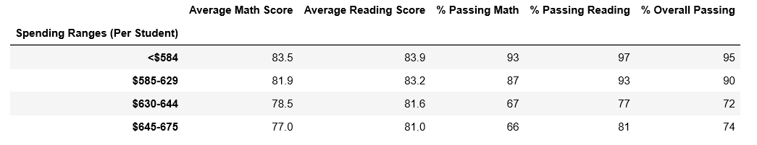

**Scores by School Size:**

Thomas High School fell into the “Medium (1000-2000)” bin for the population of students. The “Small” and “Large” school sizes were not affected by the removal of the 9th grade class; however, the % Passing Math, Reading, and Overall decreased by 5-6%. The Average Math and Reading Scores were unaffected.

Scores by school size before:

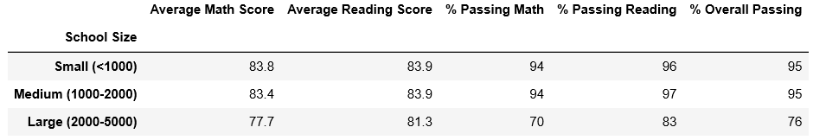

Scores by school size after:

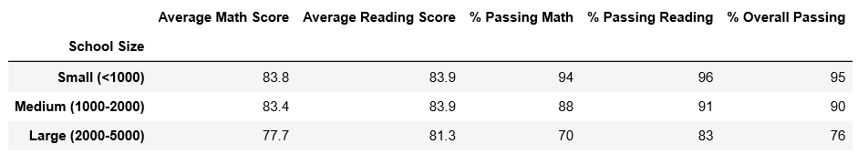

**Scores by School Type:**

Thomas High School is a Charter School, so only the “Charter” school type is affected. The % Passing Math, Reading, and Overall decreased by 3-4%. The Average Math and Reading Scores were unaffected.

Scores by school type before:

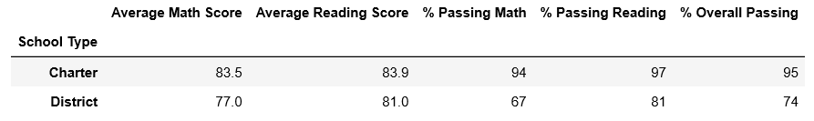

Scores by school type after:

